**EE451 PA1**

Yixuan Zhou

**P1a:**

Compile and run:

gcc -o problem1a.c problem1a

sun -n1 problem1a

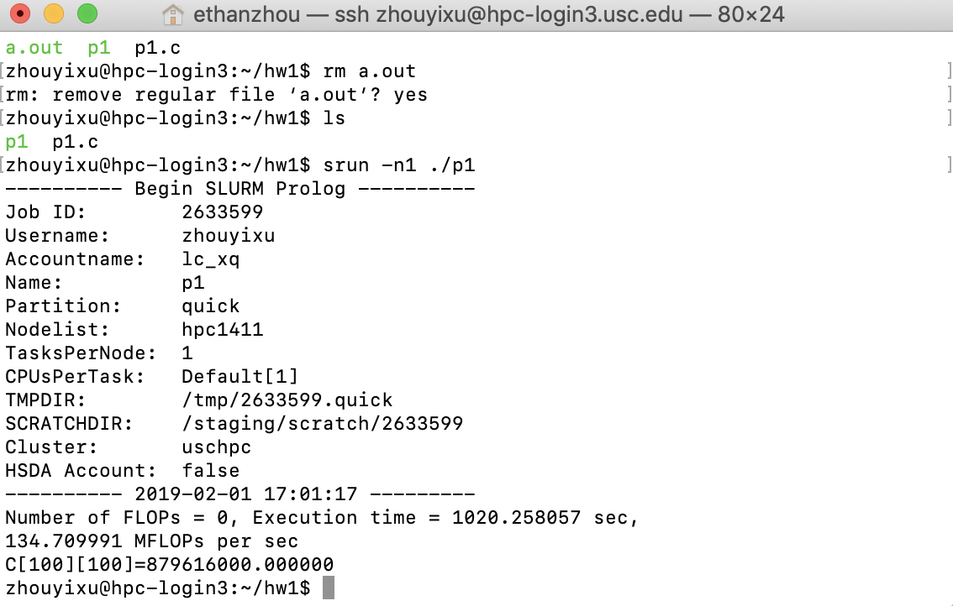

**P1b:**

Compile and run:

gcc -o problem1b.c problem1b

srun -n1 problem1b

Block Size is 4:

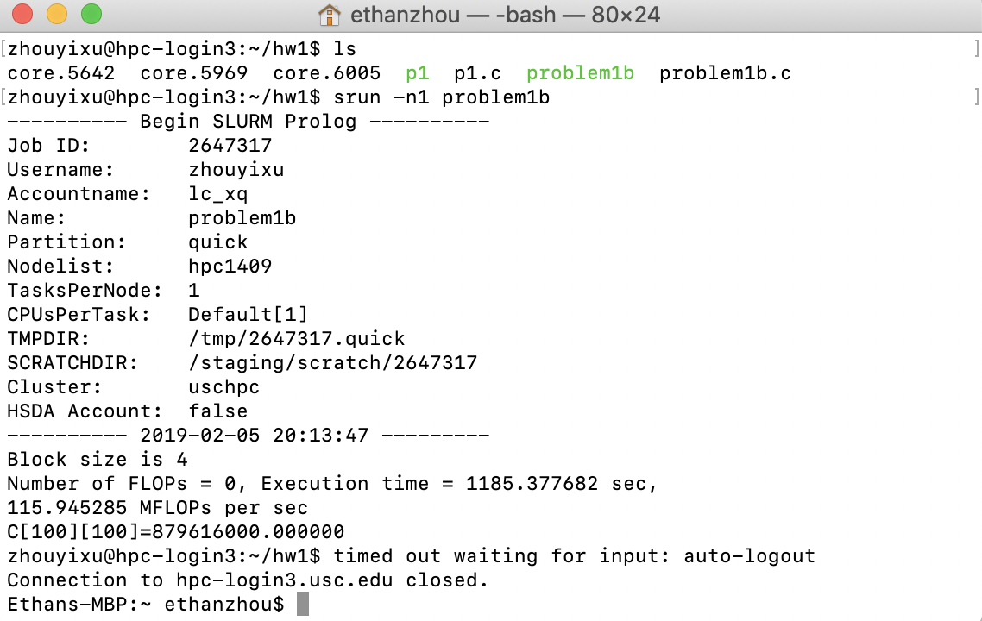

Block Size is 8:

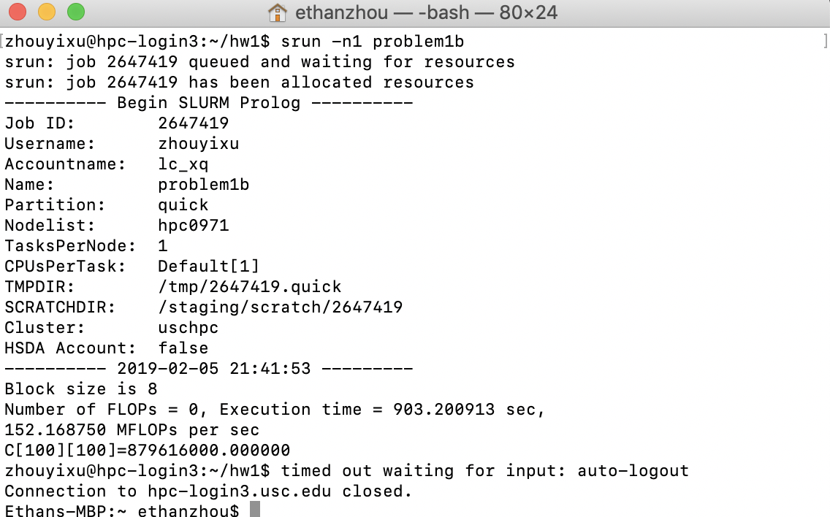

Block size is 16:

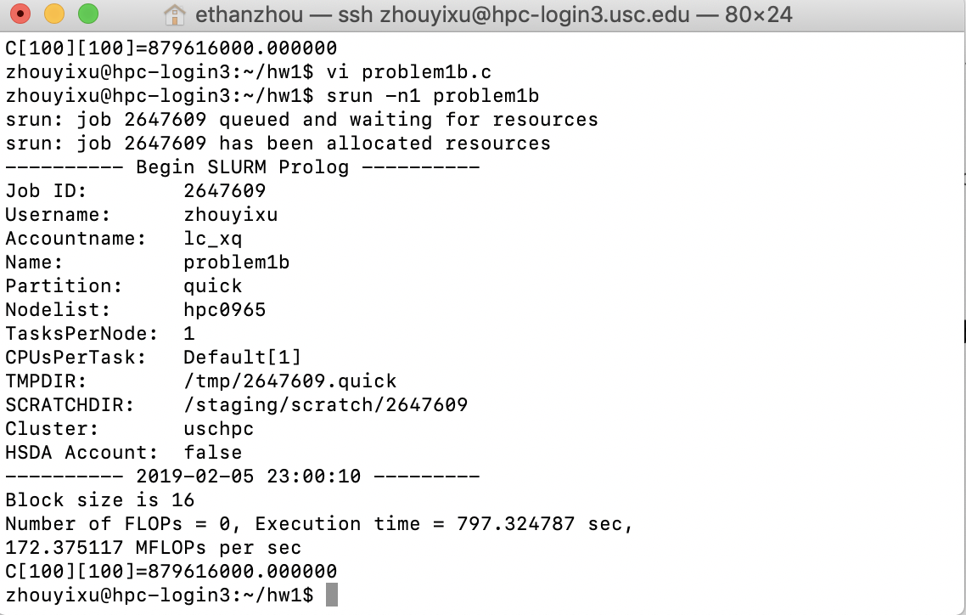

We can observe that the speed increases with larger block size!